--LAW ENFORCEMENT SYSTEM--

Output Screens With Explanation

* **Launch Screen:-**

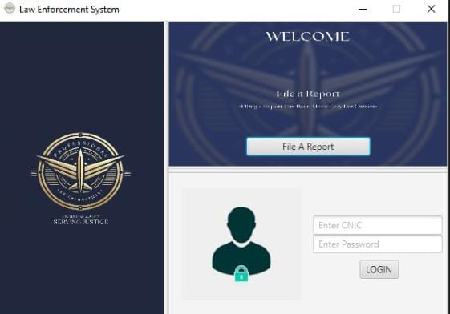 This program helps citizens file reports and executives to login. It provides a simple way for citizens to report issues. Executives can login to access and manage reports. The program aims to make reporting easy and efficient

* **File a report:-**

This screen shows our file a report method which makes provides citizen with a function to file a report. It takes the applicant name, their age ,there residence and their

CNIC number and the crime they want to report. It's backend implementation it has a string which stores the time when the file has been reported.

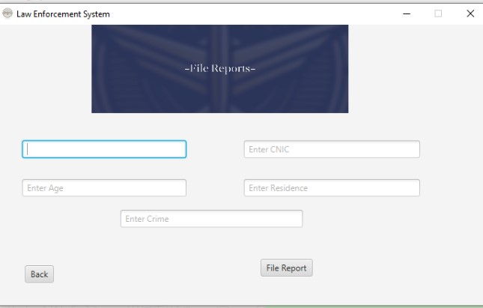

* **Executive Option:-**

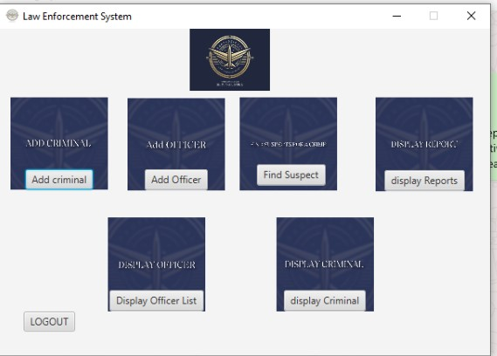 After the executive logs in he is don't many options which he can use as an executive in the police department. This gui also has log out button which takes us back to our launch screen

* **Add Criminal Method:-**

When the executive clicks on the add criminal button, brother scene open which allows the executive to enter different field related to a criminal and when he clicks the add criminal button the new criminal is added to our criminal list and it also stored in the file.

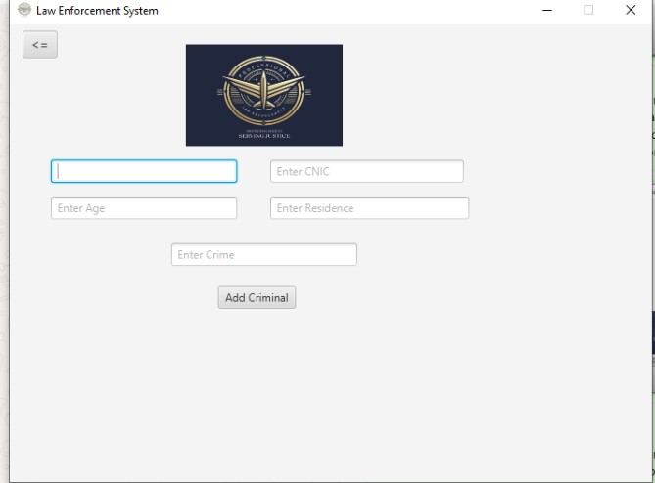

* **Add Officer:-**

When the executive clicks on the add officer button , another scene open which allows the executive to enter all the fields related to the officer and when he clicks the add button the new officer is added to our officer array list and then it is written to the file

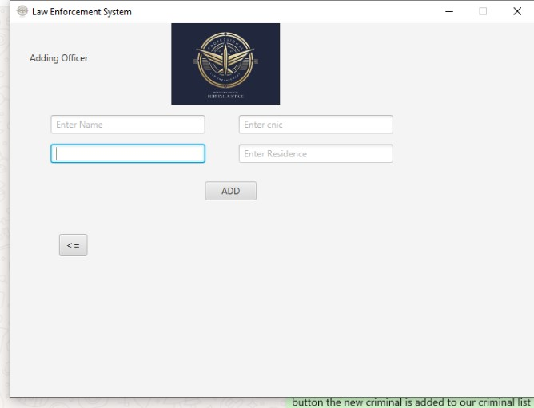

* **Display officer:-**

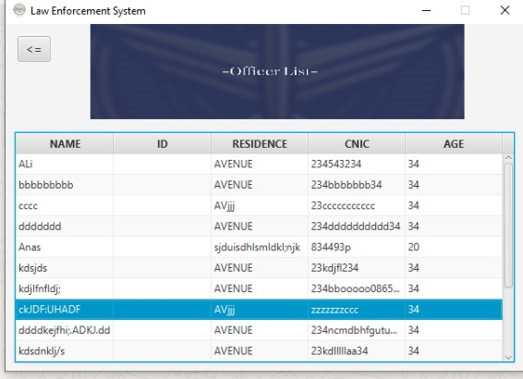 When the executive clicks on the display officer button another scene opens which first gets the data from our file and then that the array list to an observerable list and then through the observer list it shows the data through the table

* **Display Reports:-**

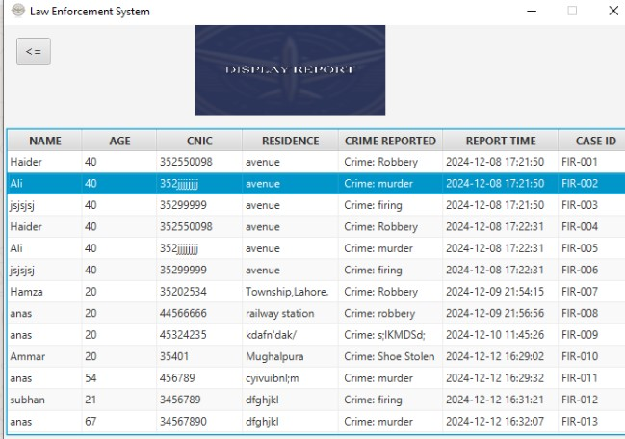When the executive clicks on the display report button , it reads the reports in our file add the array list to an observable list and then shows the list in the form of a table

* **Display Criminal:-**

When the executive clicks on the display criminal is button , it gets the data from the file and stores it is an arraylist and then add the arraylist to an observable list, and then show that in the form of a table

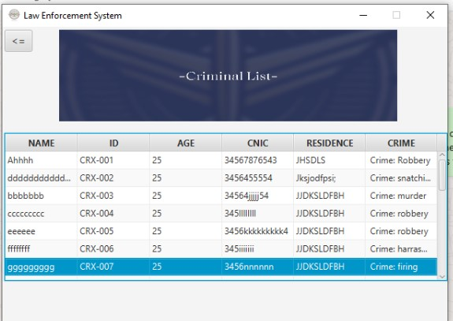

* **Find Suspects:-**

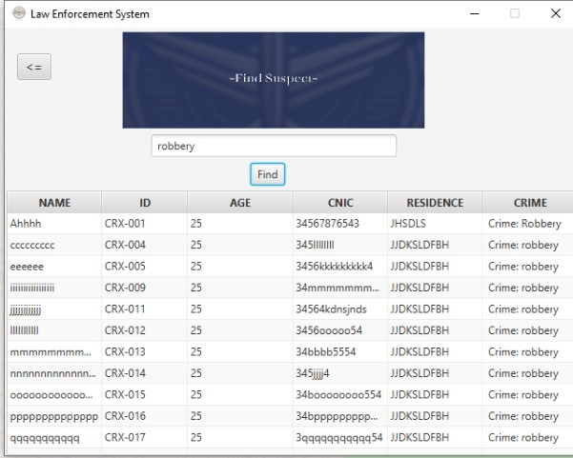 When the executive clicks on the find suspect button a scene opens which allows the executive to enter a crime, suppose the executive writes robbery in the text field when he presses the find button the table shows all the criminals which have committed robbery, this function makes it easy to find suspects for a crime.